Digital Marketing and SEO Agency.

“With over a decade of expertise, Leo Digital Studio stands as a trailblazer in digital marketing and SEO solutions. Our seasoned team crafts compelling strategies, seamlessly integrating SEO prowess to elevate your online presence. Trust Leo for unparalleled excellence in optimizing your digital success.”

Satisfied clients – 189+  
Experience Members – 18+

Projects Accomplished – 220+

About Company

Welcome to Leo Digital Studio — where a decade of profound industry experience converges with cutting-edge innovation. We are not just a digital marketing agency; we are architects of growth for businesses. Our seasoned team crafts dynamic and data-driven strategies, ensuring your digital presence not only stands out but thrives. With Leo Digital Studio, your success is not just a goal; it's a meticulously curated journey towards unparalleled digital excellence.

Top of Form

*In me jitne bhi read more hai na unko **services** pr redirect krde*

SEO OPTIMIZATION - Unlock the full potential of your online presence with SEO (Search Engine Optimization). At its core, SEO is the strategic art of enhancing your website's visibility on search engines. By optimizing content, keywords, and technical elements, SEO ensures your business is easily found by your target audience. Increased visibility translates to higher organic traffic, improved credibility, and a competitive edge in the digital landscape. Elevate your brand, reach a broader audience, and watch your business thrive with the transformative power of SEO.

E-mail Marketing- Experience the impact of targeted communication with Email Marketing. Seamlessly connect with your audience, fostering relationships and driving engagement. From personalized promotions to informative newsletters, Email Marketing enhances brand loyalty, boosts conversions, and nurtures long-term customer relationships. Elevate your business outreach and harness the proven power of Email Marketing for sustainable growth.

Web Development- Leo Digital distinguishes itself in the realm of web development by weaving a tapestry of innovation and precision for our clients. Our seasoned team doesn't just build websites; we craft immersive digital experiences tailored to each client's unique vision. What sets us apart is our commitment to marrying cutting-edge technology with a keen understanding of user behaviour, resulting in visually stunning, highly functional, and seamlessly responsive websites. At Leo Digital, we don't follow trends; we set them, ensuring our clients stand out in the digital landscape.

UI/UX Strategy- At Leo Digital, our UI/UX strategies redefine digital experiences. We stand out by meticulously blending creativity with usability, crafting interfaces that captivate and functionalities that resonate. Our team leverages a decade of expertise to curate seamless, user-centric designs that not only meet but exceed client expectations. Leo Digital transforms visions into immersive digital journeys, ensuring our clients' brands not only stand out but leave an indelible mark on the user landscape.

Digital Strategies- Leo Digital emerges as a beacon in the realm of digital strategies, setting new benchmarks for our clients' success. What defines us is our holistic approach—integrated, data-driven, and tailor-made to amplify digital footprints. From precise targeting in social media campaigns to dynamic SEO strategies, we orchestrate a symphony of tactics that propel businesses forward. Leo Digital stands at the forefront, not merely as service providers but as architects of comprehensive and effective digital success stories for our clients.

Content Creation- Leo Digital stands out as a beacon of excellence in content creation services, seamlessly blending creativity with strategic precision. Our seasoned team of content architects crafts compelling narratives that not only resonate with target audiences but also drive tangible results. From engaging blog posts to captivating multimedia content, we go beyond mere storytelling; we create digital experiences that leave a lasting impact. At Leo Digital, we redefine content creation, transforming ideas into powerful assets that elevate brands and connect them with their audience on a profound level.

Design and Branding- In the realm of design and branding, Leo Digital emerges as a true trailblazer. What sets us apart is our commitment to transforming concepts into visual narratives that resonate with authenticity and innovation. Our seasoned designers are adept at transcending aesthetic boundaries, creating distinctive brand identities that speak volumes. From logo inception to comprehensive branding strategies, Leo Digital doesn't just design; we craft visual experiences that imprint lasting impressions, ensuring our clients stand out in a crowded digital landscape.

*Lead Generation kr dio last service me*  
Leo Digital redefines excellence in lead generation services, standing as a catalyst for our clients' growth. What distinguishes us is our strategic prowess—meticulously tailoring lead generation campaigns that don't just capture attention but convert leads into valuable customers. From precision-targeted ads to compelling landing pages, we navigate the digital landscape with finesse, ensuring a steady influx of high-quality leads. Leo Digital doesn't follow trends; we pioneer data-driven methodologies that set our clients ahead in the competitive market, turning potential into measurable success.

Top of Form

Business Analysis

At Leo Digital, our business analysis process is unparalleled, ensuring 100% guaranteed results for our clients. Leveraging advanced analytics tools and a team of seasoned professionals, we conduct comprehensive assessments tailored to each client's unique needs. Our approach involves in-depth market research, competitor analysis, and a meticulous examination of industry trends. By combining data-driven insights with our extensive experience, we formulate strategies that position our clients as industry leaders. As the best digital marketing agency in Rohtak, Delhi, Gurgaon, Noida, Punjab, Rajasthan, and Maharashtra, Leo Digital doesn't just promise results; we deliver transformative success. Trust us to elevate your business to new heights through strategic analysis and unparalleled digital expertise.

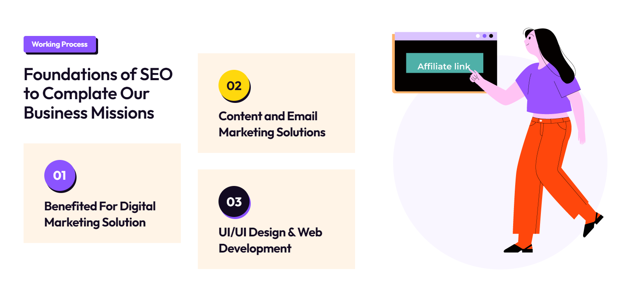

Is section me Complate ki jaghe complete krde and content and email wale me 1 krde benifited ki jaghe benefits of digital marketing solution ko 2nd krde

Is section me bars laga de

1. Research ki jaghe social media marekting me 89%
2. Development me 92%
3. Seo Me 97%

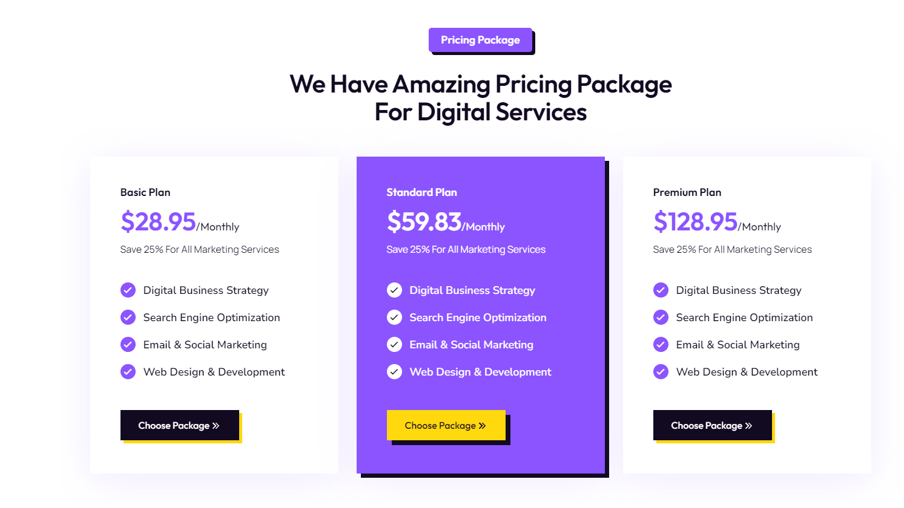

Yaha ki pricing change kre jab merko call krio me on call bata dunga terko iske.

Ye FAQ’s Work nahi kr rhe h check krio

Yaha signup ka button work nahi kr rha h usko check krle

Pointers

1. Whats app integrate krde isme
2. Color jo services ko hover krte tym ata h usko (#fffff #7ed957 90*leniar gradient) is color code pr krde
3. 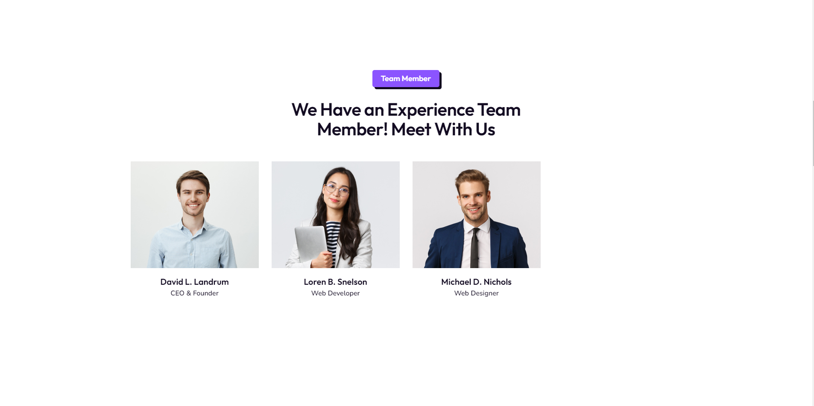
4. Iski alignment theek krde and isme CEO And founder me me ani image bhejdunga vol aga dio
5. We developer me apni laga dio
6. Web designer me jatin naam se dc ayega uski lagaio
7. Ek field or lio social media manager and seo expert ki uske Jaideep naam ke ladke ki pik ayegi
8. 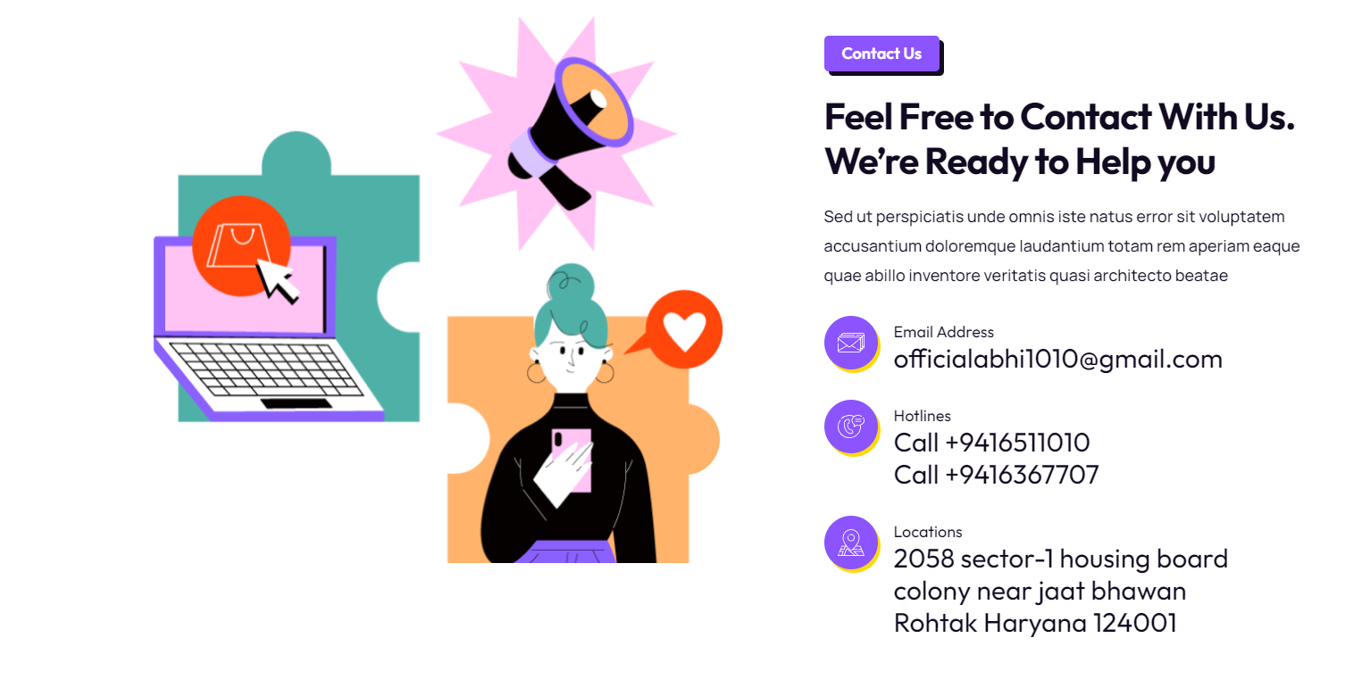
9. Feel free wali headline ke neche - Contact Leo Digital for bespoke solutions tailored to your digital needs. Our seasoned team is ready to elevate your brand. Let's craft success together.
10. 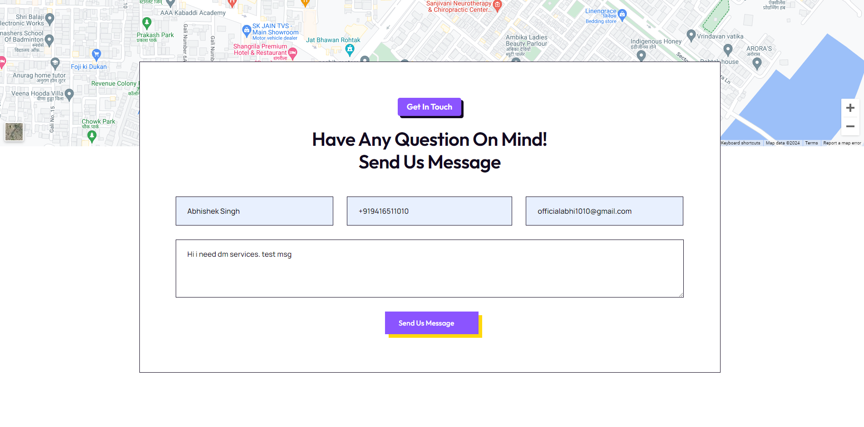
11. Ispe send msg ka button work nahi kr rha is button p merko mail aa jani chaiye basically mail hit ho ye system daal de
12. A screenshot of a phone

    Description automatically generated Header me se isko delete krde and search icon laga hua h usko bhi delete krdio